Grant Service Request Documentation

Overview:
Grant Service Request form is about requesting approval to work with already approved or qualified grant writers (vendors) so the department can get help in finding, writing, submitting and grant applications for them.

Business Problem:
Automation is built by hardcoding each vendor matching logic with requested topic area. When new vendors/topic area details need to be updated/added it requires hardcoding modification in the Power Automate flow that breaks the automation and is time consuming.
Current Workflow Diagram:
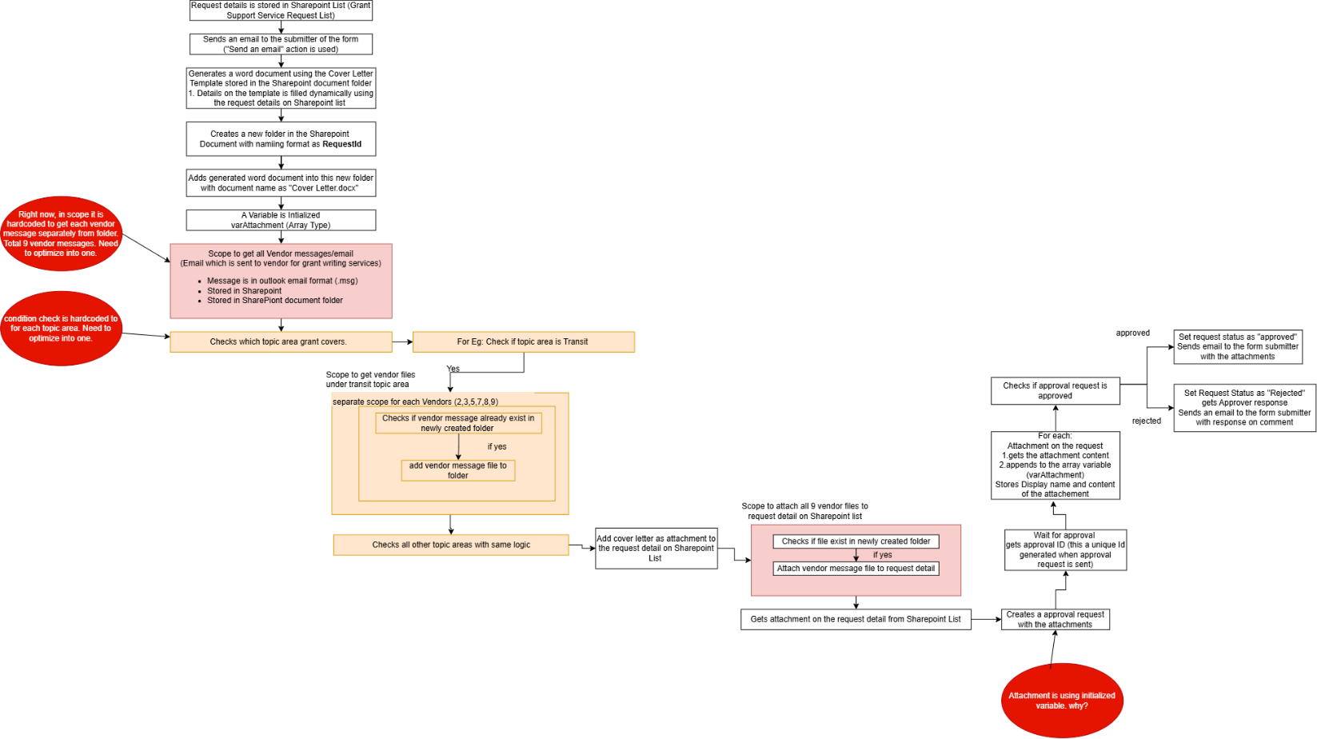

Expected Outcome:
Created a dynamic automation that doesn’t require changes in the Power Automate flow when vendor/topic area is updated/added.

Implementation:
This Automation is built using:
- Microsoft Copilot
- Power App
- Power Automate Flows
- SharePoint List
How they Interact:

Data Sources:
- New SharePoint List – New Grant Service Request
  - Stores all new incoming service requests
  - Has fields like: Grant name, Topic Area, other information fields, etc
- SharePoint List – Vendor Detail
  - Stores Vendor details and logic associated with topic area on request
  - Has Fields like: Vendor Name, Associated Topic Area, Vendor messages, etc

Solution File Location:
- Environment Name
- Solution Name

Power App Configuration
Power App Name: Grant Writing Request App
Key Features
- Form for Request Submission
- Validations
- Get inputs and pass to power automate to create new item on Grant Support Services Request List

App Structure
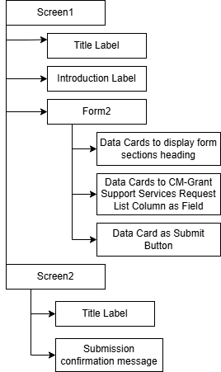
On Change Property on Submit Button:
If(
!Form2.Valid,
Notify("Please fill required fields",NotificationType.Error, 4000),
FlowName.Run(
//If field is blank and not required – pass “NA” as value
If(IsBlank(Form2.Updates.'Department Point of Contact Phone Number'),"NA",Form2.Updates.'Department Point of Contact Phone Number'),
//if field is required
Form2.Updates.'Description of project/program to be funded by grant',
//If field is date and required
DateValue(Form2.Updates.'Grant Submission Deadline'),
//If field is required and multi-select, separate by ;
Concat(DataCardValue21.SelectedItems, Value, ";"),
//If field is required and single select, get value
Form2.Updates.'Editing, Documentation, and Closeout - Support final review and documentation processes '.Value,
);
//reset form upon submission
ResetForm(Form2);
//navigate to thank you screen
Navigate(Screen2)
)

Power Automate Flow
Flow Name: GrantFlow
Trigger: When a request is submitted from Grant Service Request Form built in Power Apps
Workflow after submitting a request:
  - A new item is created in the New Grant Service Request SharePoint List
  - A confirmation email is sent to the submitter
  - A Cover letter is generated with the details using the word template stores in SharePoint Folder
  - A new folder is created in SharePoint Document using the naming format RequestID (eg: 12)
  - Matches vendor from Vendor Detail SharePoint List based on the requested topic area and retrieves all the vendor messages files
  - Cover Letter and Vendor Messages files are added to both the created folder and the request list item as an attachment
  - An approval request is sent with request details and attachments
  - Upon approval, an email is sent with the cover letter and all vendor message attached
  - Upon rejection, a rejection email is sent

Improved Process WorkFlow Structure:
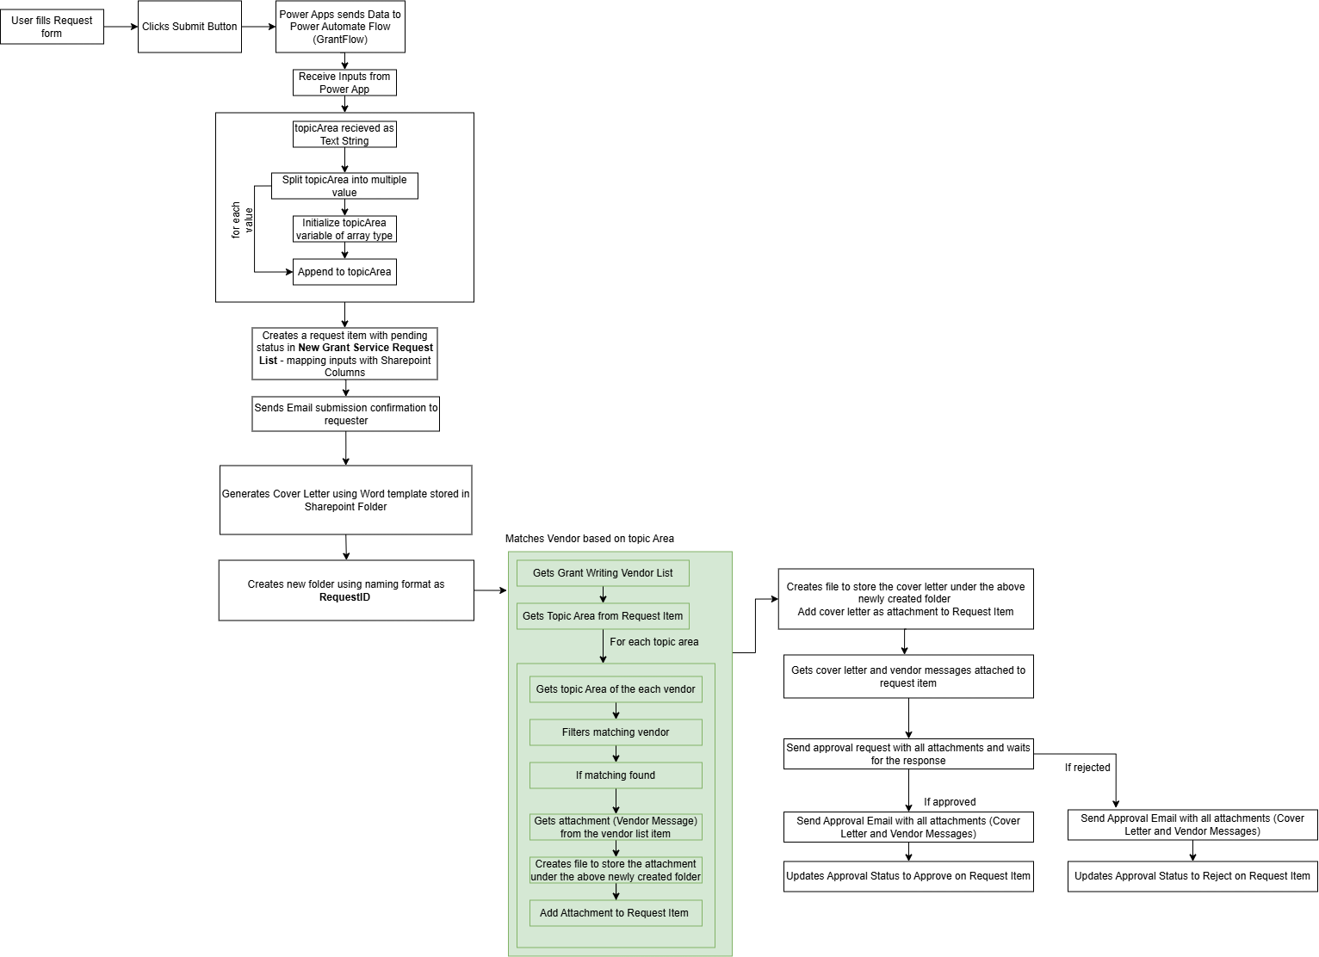

Components Used:
